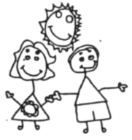
Year 5 Homework
MATHS
In Maths, we will be practising our place value knowledge up to 1,000,000. We will be rounding to the nearest 10, 100, 1000, 10,000, 100,000; adding and subtracting; rounding decimals and problem solving.
Useful websites
- Mathletics
- Maths frame
- BBC Bitesize KS2

READING/ SPELLING
Please find attached a copy of the Year 5/6 expected spelling list. Please practise at home.
Useful websites
- Purple Mash
- Spelling frame

Our topic this half term is Earth and Space and we will be looking at the movement of the Earth and other planets in relation to the sun and moon. I would like you to become a scientist and create something to impress me.
For your project, you could make a model, an information poster, a power point, a book or simply be creative and produce something that will wow us all!
Homework is due in on 27th September 2019
Useful websites you could use to help you
- http://www.planetsforkids.org/planet-earth.html
- https://www.natgeokids.com/uk/discover/science/space/ten-facts-about-space/
- https://www.themeasuredmom.com/space-activities-for-kids-2/

