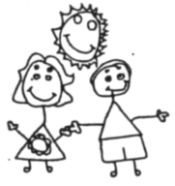
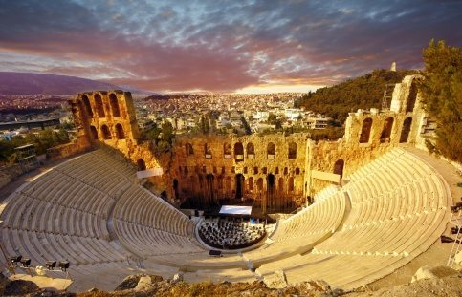
Year 5 Homework
MATHS
In Maths, we will be focusing on measure, multiplication, division and fractions. We will also be practising our times tables and our arithmetic skills. We will have weekly times tables tests.
Useful websites:
- Mathletics
- Hit the button
- Maths frame.
- TTRockstars

READING/ SPELLING
It is extremely important that you continue to read at home and practise your spellings- remember to complete your reading record. Your weekly spellings are sent home.
Useful websites:
- Bug club
- Espresso
- Purple Mash
- Oxford Owl

Our topic this half term is Ancient Greece and we will be looking at how the Greeks lived 4000 years ago. I would like you to become a historian to create something to impress me.
For your project, you could make a model, an information poster, a power point, a book or simply be creative and produce something that will wow us all!
Homework is due in on 29th November 2019
Useful websites you could use to help you:
- BBC Bitesize
- natgeokids
- ducksters

