Publication of Executive Pay | 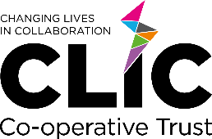

Publication of Executive Pay In accordance with the Education & Skills Funding Agency’s (ESFA) Academy Trust Handbook 2023:
(2.32) The Trust must publish on its website in a separate readily accessible form the number of employees whose benefits exceeded £100k, in £10k bandings, for the previous year ended 31 August. Benefits for this purpose include salary, employers’ pension contributions, other taxable benefits and termination payments.
Changing Lives in Collaboration Trust - Company Registration No: 09748195 (England and Wales)
Annual Report and Accounts for the year end 31 August 2024
Number of employees whose benefits exceeded £100k as at 31 Aug 2024

Employee Salary Employer’s Pension Employer’s NI
Employee x1 £120,001 - £130,000 £30,001 – £40,000 £10,000-£20,000

